Debug log for bug “Incorrect payout”

Initial example of bug

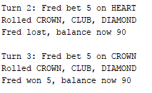

Output from automated test

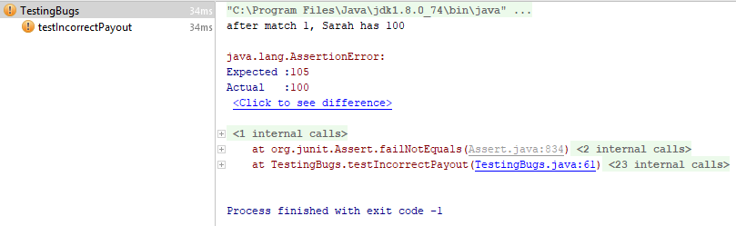

Log:

|  |  |
| --- | --- |
| **Step reasoning** | Issue could be UI where results aren’t displayed correctly |
| **Hypothesis 1** | Automated test has been written, so output of data to screen should be correct -> this is not a UI issue |
| **Test** | Debug mode and verify values that go into the console print command |
| **Prediction** | The values passed in will be the same as printed to the screen |
| **Result** | Correct, values passed into print statement display correctly, values are same |

|  |  |
| --- | --- |
| **Step reasoning** | Stepping back through code, game.getDiceValues is only a get method, it should be getting the values from the previous game that run for display. Game.playRound is next. |
| **Hypothesis 2** | player.receiveWinnings in game.playRound is not adding winnings correctly |
| **Test** | Debug mode and step into player. receiveWinnings, see if balance is modified before adding to player |
| **Prediction** | Balance will be modified by recieveWinnings |
| **Result** | Balance was not modified by receiveWinnings, balance is same at this point |

|  |  |
| --- | --- |
| **Step reasoning** | Player.recieveWinnings effectively fulfils its method contract, therefore the value passed into recieveWinnings must be the issue, possibly a calculation issue when generating value. |
| **Hypothesis 3** | When calculating winnings, the number of matches found is incorrect |
| **Test** | Check the raw values of the dice rolls and compare it to the count of matches found |
| **Prediction** | The number of matches found is always 1 short when matches is > 0 (Actually matches the issue) |
| **Result** | This is incorrect, number of matches found is correct, ’matches’ is same at this point |

|  |  |
| --- | --- |
| **Step reasoning** | Reading the rules of the games, a player better x amount, when 1 match occurs should be returned their bet + win the value of the bet (1:1). This calculation of winnings is incorrect |
| **Hypothesis 4** | The calculation of winnings is incorrect; the player is not returned their initial bet as well as their winnings, winnings are affected |
| **Test** | Change code to add the initial bet to the winnings calculation only when player has won, run automated test for IncorrectPayoutBugFixed |
| **Prediction** | Automated test will run successfully; bug will be resolved |
| **Result** | Prediction is correct, bug is resolved |

Successful automated test result

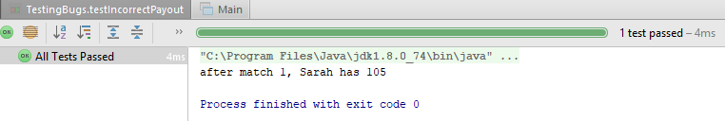

Initial bug, /src/Game.java, line 42

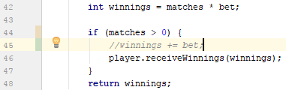

Resolved bug, /src/Game.java, line 45

